To make it a little easier to show the prototype as a demo we created some hidden buttons that control the verification process.

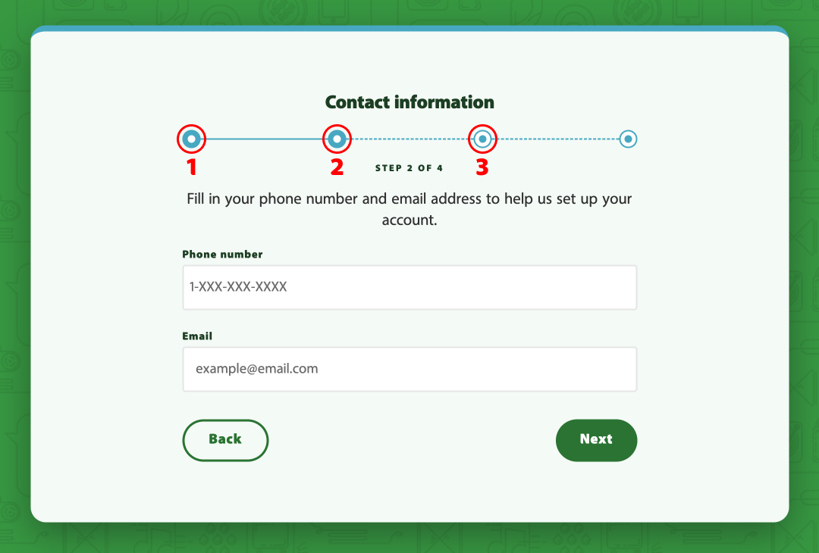

Clicking on any of the first three dots will set a variable allowing you to show the process that, in practice would be calls to APIs to verify the users account. Each button corresponds to the three options in the image below (next page).
